Cronfa - Swansea University Open Access Repository_______________________________________________________________________
This is an author produced version of a paper published in:
Cronfa URL for this paper:
http://cronfa.swan.ac.uk/Record/cronfa39618
_______________________________________________________________________
(2018).
http://dx.doi.org/10.1111/anae.14300
_______________________________________________________________________
This item is brought to you by Swansea University. Any person downloading material is agreeing to abide by the terms of the repository licence. Copies of full text items may be used or reproduced in any format or medium, without prior permission for personal research or study, educational or non-commercial purposes only. The copyright for any work remains with the original author unless otherwise specified. The full-text must not be sold in any format or medium without the formal permission of the copyright holder.
Permission for multiple reproductions should be obtained from the original author.
Authors are personally responsible for adhering to copyright and publisher restrictions when uploading content to the repository.
http://www.swansea.ac.uk/library/researchsupport/ris-support/
TITLE PAGE

Dr John Dingley FRCA MD
Department of Anaesthetics
Morriston Hospital
Swansea SA6 6NL.
United Kingdom.

Texture analysis of i-gel cuffs with increasing temperature to investigate one mechanism of possible changes in sealing efficiency after insertion.
J. Dingley,¹ J. Stephenson,² V. Allender,³ S. Dawson⁴ and D. Williams.⁵

1 Associate Professor and Honorary Consultant Anaesthetist. Swansea University College of Medicine, Swansea, United Kingdom.

2 Graduate student. Swansea University College of Medicine, United Kingdom.

3 Head of Department of Healthcare and Food, Cardiff School of Sport and Health Sciences, Cardiff Metropolitan University, Cardiff, United Kingdom.

4 Lecturer, Food Science & Technology, Department of Healthcare and Food, Cardiff School of Sport and Health Sciences, Cardiff Metropolitan University, Cardiff, United Kingdom.

5 Consultant Anaesthetist and Honorary Associate Professor. Welsh Centre for Burns. ABM University Health Board, Swansea. United Kingdom.

Correspondence to:
Dr John Dingley FRCA MD
Department of Anaesthetics
Morriston Hospital
Swansea SA6 6NL.
United Kingdom.
Tel: 00 44 1792 703280
Fax: 00 44 1792 703278
j.dingley@swan.ac.uk
JohnDingley98@gmail.com

Short title: Texture analysis of i-gel cuffs with increasing temperature

Suggested keywords: Supraglottic Airway Device; i-Gel; Airway Management.

SUMMARY
The i-gelTM is a supraglottic airway with a gel-like thermoplastic cuff. It has been suggested that the seal against the larynx improves over time. Perhaps the most intuitive explanation proposed for this is cuff softening on warming from ambient to body temperature. We investigated this using a food industry texture analyser machine over a wide temperature range.
Size #2 and #3 i-gelsTM were secured to a platform within a temperature-controlled water bath, mounted on a texture analyser test stand. Both water and i-gelTM cuff temperatures were recorded. A spherical probe advanced 4mm into the surface of each i-gelTM at 1mm/s then retracted at the same rate while the upward pressure on the probe was recorded at 200Hz. Three runs made at each of 11 temperatures (10°C to 60°C, 5°C increments) gave 105,864 data points from which values for hardness (the peak force on the probe at maximum indentation), and resilience (the rate at which the material recovers its original shape), were calculated.
Over 10°C-60°C the smallest hardness value expressed as a percentage of the largest was 88.2% and 89.8% for #2 and #3 i-gelsTM respectively. For resilience these were 92.8% and 86.2% respectively. Over a room temperature (21°C) to body temperature (37.4°C) range, hardness decreased by 3.15%, and increased by 0.47% for sizes #2 and #3 respectively, with resilience values decreasing by 1.85% and 2.68% respectively.
Although cuff hardness and resilience do generally reduce with warming, the effect is minimal, especially over the temperature ranges encountered in clinical use.

INTRODUCTION
The i-gel™ (Intersurgical, Wokingham, UK) is a single-use supraglottic airway invented by an anaesthetist, Dr. M Nasir and introduced into clinical practice in the UK in 2007. It has a wide flat stem which acts as a bite block and reduces rotational malpositioning, an oesophageal vent, and a soft non-inflatable cuff made of a gel-like thermoplastic elastomer, styrene ethylene butadiene styrene.
Some authors have observed that the sealing pressure of the gel-like cuff against the tissues of the larynx improves over time compared to the situation immediately after initial insertion [1-13]. One mechanism proposed to explain this is that the material from which the i-gel cuff is manufactured may soften with warming and thus conform to the anatomy of the larynx as it approaches body temperature [3, 5, 6, 8, 9, 10]. This view has also been expressed on-line in nurse anaesthesia and first-aid forums [14,15].
An i-gelTM cuff is made of a thermoplastic material which by definition means a substance that becomes plastic or softens on heating and hardens on cooling, a property which facilitates manufacture by injection moulding. It may be that use of the word thermoplastic to classify this cuff material may be responsible for an assumption that the cuff softens as it warms up to body temperature post-insertion. It also appears to have at least been suggested, as a common misconception, that the polymer of the cuff might physically expand on heating and that it is this effect, as opposed to softening, which may improve the sealing properties after initial insertion as it warms to body temperature [15].
Against this background previous investigators have examined the effect of warming i-gelsTM to 42°C for 30 minutes or keeping them at room temperature before insertion. The pre-warmed i-gelsTM showed smaller leak volumes 30 seconds after mechanical ventilation initiation [16], although in another study by the same authors this finding was not replicated in non-paralysed, sedated patients [17].
In order to investigate this further we could reasonably examine whether there are any softening effects on the cuff material with increasing temperature as this appears to be the most commonly held view, and possibly the most intuitive, as a potential mechanism by which this phenomenon might occur.
Texture analysers are instruments used in engineering for testing the properties of materials, such as hardness, and variants are widely used in the food industry for testing the properties of foodstuffs, including gels.
In this study we have evaluated the texture of i-gelTM cuffs over a wide range of temperatures using a laboratory texture analyser apparatus designed for this purpose.

METHODS
Opinion was sought from our Regional Ethics Committee and formal review was not required for this type of investigation.
Two different sizes of i-gelTM (#2 and #3) were tested, representing a size commonly used for paediatric patients and one commonly used in adults. An insulated laboratory water bath containing a thermostatically controlled heating element and water recirculation pump (Tempette Junior, Techne, Minneapolis, Minnesota, USA) was used to control the temperature of the i-gelTM under test. The i-gelTM to be tested was affixed to a custom made platform, beneath the surface of the water, so that the underside of one lateral side of the gel cuff was in full contact with the upper surface of the platform with no space between these two surfaces (Figure 1). This water bath was mounted in its entirety upon the base platform of a food texture analyser machine (TA/XTPlus, Stable Microsystems, Godalming, Surrey, UK). The sensor tip of a previously calibrated digital thermometer (Model F338, Hygiplas, Avonmouth, UK) was mounted to a depth of 4cm below the surface of the water to measure the water bath temperature.
The 4.8mm diameter tip of a flexible temperature sensor probe (YSI400 Series, Harvard Apparatus, Cambourne, Cambridge, UK) was inserted to a depth of 8mm into the distal oesophageal vent port of the i-gel, forming a close interference fit and attached to a temperature monitor (TM-200D, SIMS, Timperley, Altrincham, UK) in order to measure the temperature of the i-gelTM cuff material.
During each experimental series of measurements the food texture analyser machine was controlled by an attached computer running dedicated software (Exponent, Stable Microsystems, Godalming, Surrey, UK). This machine was fitted with a spherical 7mm diameter stainless steel test probe which was set to advance slowly towards the upward facing surface of the i-gelTM cuff, compress a portion of the cuff material slightly, in a repeatable manner and then reverse direction. Whilst carrying out this automatic manoeuvre, a force transducer above the test probe, onto which the test probe was mounted, measured the upwards force acting on the probe as it was pushed into, or removed from, the surface of the i-gelTM material.
At the start of each test run the probe was programmed to advance towards the surface of the i-gelTM at 1.5mm per second. On contact with the i-gelTM surface, defined as a measured upward force on the probe of 5g, the computer commenced recording of i) the upward force on the probe, ii) the position of the probe along the vertical axis and iii) the current time, at 5 millisecond intervals. After initial contact with the surface, the probe thereafter advanced 4mm into the surface of the i-gelTM, deforming it slightly, at a rate of 1mm per second. After advancing 4mm into the surface it then reversed direction, moving upwards again, withdrawing the probe from the i-gelTM surface at the same rate of 1mm per second. Once the upward force on the probe, generated by contact with the i-gelTM, fell below 5g, the data recording stopped. For each run a graph of distance on the x-axis against force on the y-axis produced an upward curve as the probe pushed into the surface, a maximum value when at the full depth of 4mm, followed by a downward curve as the probe slowly withdrew from the i-gelTM surface. These test settings were selected from the texture analysis software package as appropriate for the testing of gels.
The temperature of the water bath was adjusted so that measurements of the properties of the i-gelTM could be made at 11 fixed temperatures (isotherms) ranging from 10°C to 60°C in 5 degree increments. At the lower end of this range, ice was added to the water bath to achieve the desired temperature. The target i-gelTM temperature was considered to have been reached when its temperature was within ±0.3 degrees of the target value as measured by the temperature probe mounted within the i-gelTM itself. The mean of three texture analysis measurements at each target i-gelTM temperature was taken.
For each size of i-gelTM (#2 and #3), 1604 datasets of; elapsed time (s), distance moved by probe from the initial point of contact with the surface of the i-gelTM (mm) and resulting force measured by probe (g) were collected at a sampling frequency of 200 Hz. Three such datasets were collected at each of the 11 isotherms (10°C to 60°C in 5°C increments) All datasets were successfully collected with no drop-outs, a total of 105,864 measurements. Data were saved as individual comma delimited (.csv) spreadsheet files, and the mean values of each isotherm were used for analysis. Initial data manipulation was performed using Microsoft Excel (Microsoft, Redmond, Washington, US) and curve plotting and analysis was performed using bespoke routines written by DW in the scientific programming language Python (www.python.com). The following indices were calculated from the data: hardness, hysteresis loop area, and resilience (Fig 2).
Hardness (g): is the peak force (g) exerted on the transducer and occurs at maximal descent of the probe with maximum indentation of the material under test.
Hysteresis (Gk. ὑστέρησις “Lagging behind”): is a phenomenon in physical and social sciences, characterised by non-linear behaviour in which the output of a system is dependent on not only the value of the input, but also on the history of previous inputs. In mechanics, elastic hysteresis occurs during loading and unloading of deformable substances, resulting in a loop on a plot of force versus extension. The area enclosed by the loop represents the energy dissipated due to material internal friction. This concept is familiar to anaesthetists in the form of pressure-volume loops of lung compliance: the additional energy required to recruit alveoli during inspiration results in the characteristic hysteresis loops.
In this study, plots of force against distance of penetration of the probe tip into the i-gelTM surface produced a series of hysteresis loops, one loop at each temperature, for each i-gelTM studied. An example is shown in Figure 2a. Elastic hysteresis is also dependant on rate of deformation: rapid loading and unloading causes greater hysteresis [18]. In this investigation the rate of loading and unloading was the same in each experimental run, i.e. the probe moved into and out of the surface of the material at 1mm/s. This leads on to the engineering concept of resilience, which is the more appropriate term in the context of materials testing.
Resilience is a dimensionless quantity which describes how rapidly a substance returns to its original height following compression. It is calculated by dividing the upstroke energy by the downstroke energy; given by the areas indicated under the curve of force against time. An example is shown in Figure 2b. In this study, these areas were measured using an implementation of Simpson’s Method for definite integrals.
Data were visualised as plots of force (g) on the y-axis against dual x-axes of elapsed time (s), and therefore probe position, relative to the surface of the i-gelTM, measured as distance (mm). The high density and overlap of the curves necessitated the use of colour (rather than line style) to differentiate the isotherms in the plots. We therefore applied “colour-blind safe” design principles and colour palettes [19], and checked the results for legibility using colour blind simulator software (www.vischeck.com) [20].

RESULTS
Reproducibility was very high with very small standard deviations within each set of three measurements made at each isotherm, and the mean values were used for analysis.
The results for hardness and resilience at each isotherm are shown in Table 1. The curves of force versus distance of penetration into the i-gelTM cuff surface at each isotherm for each size of i-gelTM are shown in Figures 3 and 4 respectively.
It can be seen that the peak force on the probe when at its maximum 4mm penetration into the cuff surface of both i-gelTM sizes tested, reflecting the hardness of their cuffs, did reduce as the temperature increased. Over the temperature range studied of 10°C to 60°C the smallest value for hardness expressed as a percentage of the largest hardness value was 88.2% and 89.8% for the #2 and #3 i-gelsTM respectively.
For both sizes of i-gelTM as the temperature was increased, the resilience, reflecting how rapidly a substance regains its original height following compression, in general decreased although this was non-linear. Over the temperature range studied of 10°C to 60°C the smallest value for resilience expressed as a percentage of the largest resilience value was 92.8% and 86.2% for the #2 and #3 i-gelsTM respectively.
The results in Table 1 were plotted (Fig 5, 6) and also modelled as 3rd degree polynomial curves using bespoke code written in Python in order to accurately interpolate values of hardness and resilience at ambient temperatures of 21.0°C (nominal room temperature) and 37.4°C (nominal body temperature).
Over the range of temperatures expected in clinical use, i.e. room temperature (21°C) to human body temperature (37.4°C), then by extrapolation from these curves, the hardness of the #2 i-gelTM decreased from 545.76g to 528.59g (a change of - 3.15 %), and that of the #3 i-gelTM increased from 691.09g to 694.37g (+ 0.47 %). The resilience of the #2 i-gelTM decreased from 0.83 to 0.82 (-1.85%), and that of the #3 i-gelTM decreased from 0.93 to 0.91 (-2.68 %).
To reflect a more extreme pre-hospital usage situation on a cold day where a paramedic inserts an i-gelTM which has been stored at 10°C into a patient at normal body temperature (37.4°C) then again, from these curves over this wider temperature range the hardness of the #2 i-gelTM decreased from 556.45g to 528.59g (- 5.01 %), and that of the #3 i-gelTM increased from 688.89g to 694.37g (+ 0.80 %). The resilience of the #2 i-gelTM decreased from 0.820 to 0.817 ( - 0.31%), and that of the #3 i-gelTM decreased from 0.910 to 0.907 (-2.52 %).

DISCUSSION
I-gelsTM are made from a thermoplastic elastomer. The word “thermoplastic” means that this type of material will soften on heating and so it may seem very reasonable to assume that i-gelsTM soften as they warm to body temperature. However, these elastomers typically have a melting point above 200°C and so the key issue is whether, over the temperatures encountered in clinical use, there is likely to be any clinically relevant softening of the cuff.
By mounting the i-gelTM in a fixed position within the water bath, and mounting the water bath upon the test stand, it was possible to repeat each test on the same part of the i-gelTM without any inadvertent movement, which would have presented a different part of the i-gelTM to the test probe, possibly of a different thickness, making any data difficult to interpret. The probe advanced and retracted at a constant rate causing the same rate of deformation of the i-gelsTM in each case. The modest test depth of 4mm was selected to prevent any damage to the surface from the testing itself. The repeatability within each of the three measurements at each temperature also supports this.
All the curves showed similar peak force or hardness although there was a trend for the hardness to decrease slightly with increasing temperature. The resilience also decreased slightly with increasing temperature, which can be thought of as a slightly slower rate of return to the original shape of the i-gelTM under test.
The peak values (hardness) and resilience were slightly smaller with the #2 i-gelTM compared to the #3. This may be a consequence of the measured force being a function of the thickness and/or volume of material tested under the chosen contact point of the probe for each of these i-gelsTM.
However, over the range of temperatures expected in clinical use, i.e. room temperature (21°C) to human body temperature (37.4°C) the hardness of the #2 i-gelTM decreased by only 3.15 %, and that of the #3 i-gelTM increased by a mere 0.47 % while their resilience decreased by 1.85% and 2.68% respectively.
When we considered a more extreme pre-hospital usage situation on a cold day where an i-gelTM at 10°C is inserted into a patient at 37.4°C the hardness of the #2 i-gelTM would still only be expected to decrease by 5.01 %, and that of the #3 i-gelTM increase by 0.80 % while their resilience would only decrease by 0.31% and 2.52% respectively.
These changes are so small that it is unlikely therefore that in clinical use, cuff softening as an i-gelTM warms to body temperature is a mechanism by which the seal pressure or “fit” of an i-gelTM might improve with time after initial insertion.
Although we did not test physical expansion of the cuff with temperature, as opposed to cuff softening, it is noteworthy that the coefficient of linear expansion of styrene ethylene butadiene styrene, i.e. the fractional change in length per °C is 16 x 10⁻⁵ and so physical expansion in size with warming to body temperature is also unlikely to be a mechanism by which the seal might improve with time after insertion [21].
Possible alternative explanations for this observation might be that; interstitial fluid redistributes in the areas in direct contact with the cuff so improving the seal slightly over time, an interaction between saliva and the cuff material alters its properties, or that the i-gelTM migrates after insertion into a position of better fit.
In conclusion, we have found that both the hardness and resilience or rate at which the cuff material returns to its original shape, do generally decrease with warming. However, these changes are very small, particularly over the temperature range likely to be encountered in clinical use and we suggest that cuff softening is unlikely to be a mechanism by which the seal pressure or “fit” of an i-gelTM might improve with time after insertion.

ACKNOWLEDGEMENTS
None.

COMPETING INTERESTS
None.
REFERENCES

1. Janakiraman C1, Chethan DB, Wilkes AR, Stacey MR, Goodwin N. A randomised crossover trial comparing the i-gel supraglottic airway and classic laryngeal mask airway. Anaesthesia 2009; 64: 674–8.

2. Russo SG, Cremer S, Eich C, et al. Magnetic resonance imaging study of the in vivo position of the extraglottic airway devices i-gel™ and LMA-Supreme™ in anaesthetized human volunteers. British Journal of Anaesthesia 2012; 109: 996–1004.

3) Gabbott DA, Beringer R. The i-gel supraglottic airway: A potential role for resuscitation? Resuscitation 2007; 73: 161–2.

4)Theiler LG, Kleine-Brueggeney M, Kaiser D, et al. Crossover comparison of the laryngeal mask supreme and the i-gel in simulated difficult airway scenario in anesthetized patients.
Anesthesiology 2009; 111: 55–62.

5) Sohn L, Nour R, Jagannathan N. Update on Airway Devices. Current Anesthesiology Reports 2015; 5: 147–155.

6) Chauhan G, Nayar P, Seth A, Gupta K, Panwar M, Agrawal N. Comparison of clinical performance of the I-gel with LMA proseal. Journal of anaesthesiology and clinical pharmacology 2013; 29: 56-60.

7) Danha RF, Sreevathsa S, Crombie N, Hillermann C, Mendonca C. Positive Pressure Ventilation with i-gel versus LMA-Unique: A Randomised Comparative Study. Journal of Anesthesia & Clinical Research 2011; 2: 173.

8) Dwivedi Y, Gupta A, Srivastava U, Jagar KD, Mohan A, Mangla S. Comparison of i-gel™, LMA Proseal™ and LMA Classic™ in spontaneously breathing pediatric patients. Anaesthesia Pain and Intensive Care 2016; 20(2): 176-81.

9) Jadhav PA, Dalvi NP, Tendolkar BA. I-gel versus laryngeal mask airway-Proseal: Comparison of two supraglottic airway devices in short surgical procedures. Journal of Anaesthesiology, Clinical Pharmacology 2015; 31(2): 221–5.

10) Abdullah MZ, Izaham A, Manap NA, Rahman RA, Zain JM, Dan A. Comparison of I-gelTM and LMA-SupremeTM With Respect To Ease Of Insertion, Sealing Airway Pressure And Postoperative Throat Complaints. The Internet Journal of Anesthesiology 2015; 34(1). DOI: 10.5580/IJA.25993

11) Taxak S, Vashisht K, Kaur KP, Ahlawat G, Bhardwaj M. A study to evaluate fibreoptic-guided intubation through the i-gel™. Southern African Journal of Anaesthesia and Analgesia 2013; 19(2): 120-3.

12) Jindal P, Rizvi A, Sharma JP. Is i-gel a new revolution among supraglottic airway devices? A Comparative Evaluation. The Middle East Journal of Anesthesiology 2009; 20(1): 53-8.

13) Teoh WHL, Lee KM, Suhitharan T, Yahaya Z, Teo MM, Sia ATH. Comparison of the LMA Supreme vs the i-gelTM in paralysed patients undergoing gynaecological laparoscopic surgery with controlled ventilation. Anaesthesia 2010; 65: 1173–9.

14) Nurse Anesthesia forum. Anaesthesia Equipment, 2012 http://www.nurse-anesthesia.org/archive/index.php/t-15423.html (accessed 01/01/2017).

15) REAL First Aid Ltd. Laryngeal Airways, 2017 http://www.realfirstaid.co.uk/laryngeal-airways/ (accessed 01/01/2017).

16) Komasawa N, Nishihara I, Tatsumi S, Minami T. Prewarming of the i-gel facilitates successful insertion and ventilation efficacy with muscle relaxation: a randomized study. Journal Of Clinical Anaesthesia 2014; 26(8): 663–7.

17) Komasawa N, Nishihara I, Tatsumi S, Minami T. Does prewarming the i-gel supraglottic airway device fit the larynx better compared to keeping it at room temperature for non-paralysed, sedated patients: a randomised controlled trial. British Medical Journal Open 2015; 5: e006653. doi: 10.1136/bmjopen-2014-006653

18) Hopkinson B, Williams GT. The Elastic Hysteresis of Steel. Proceedings of the Royal Society 1912; 87(598): 502-511.

19) Wong B. Points of view: Color blindness. Nature Methods 2011; 8: 441.

20) Brettel H, Viénot F, Mollon JD. Computerized simulation of color appearance for dichromats. Journal of the Optical Society of America 1997; 14(10): 2647-55.

21) Drobny J. Properties of styrene-ethylene butylene-styrene block copolymers. In: Drobny J. (eds) Specialty Thermoplastics. Landolt-Börnstein - Group VIII Advanced Materials and Technologies (Numerical Data and Functional Relationships in Science and Technology). Berlin, Heidelberg: Springer, 2015: 139-42.

Table 1 Hardness (g), and resilience for size 2 and size 3 i-gelsTM at 11 isotherms of 10°C to 60°C in 5°C increments.

 | Size 2 i-gelTM |  | Size 3 i-gelTM
Temperature  (°C) | Hardness  (Peak Force)  (g) | Resilience | Hardness  (Peak Force)  (g) | Resilience
10 | 556.45 | 0.82 | 688.89 | 0.93
15 | 549.93 | 0.83 | 693.58 | 0.94
20 | 547.28 | 0.83 | 697.26 | 0.93
25 | 542.19 | 0.83 | 699.81 | 0.93
30 | 537.80 | 0.83 | 697.74 | 0.92
35 | 530.86 | 0.82 | 702.52 | 0.91
40 | 524.01 | 0.82 | 696.45 | 0.90
45 | 519.09 | 0.80 | 687.13 | 0.88
50 | 511.34 | 0.79 | 674.48 | 0.87
55 | 499.51 | 0.77 | 657.05 | 0.84
60 | 490.64 | 0.77 | 630.68 | 0.81

Captions for figures

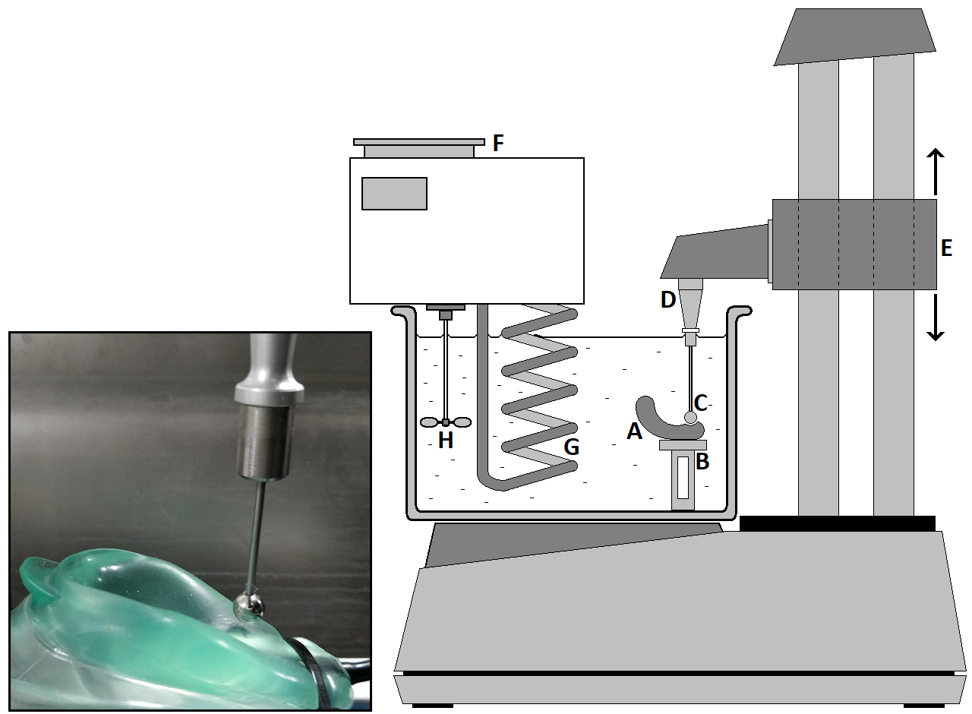
Figure 1. Apparatus (inset: photograph of measurement in progress). The i-gelTM under test (A) is mounted on a metal platform (B) within a water bath. The circular probe (C) of the texture analyser machine indents the surface of the i-gelTM cuff and then reverses direction. During this manoeuvre the force acting on the probe is measured by a force transducer (D) mounted on a sliding arm (E) which moves up and down under computer control. An adjustable temperature control unit (F) maintains the water temperature via a heater coil (G) and stirrer (H). Thermometers for measurement of water temperature and i-gelTM cuff temperature are not shown.

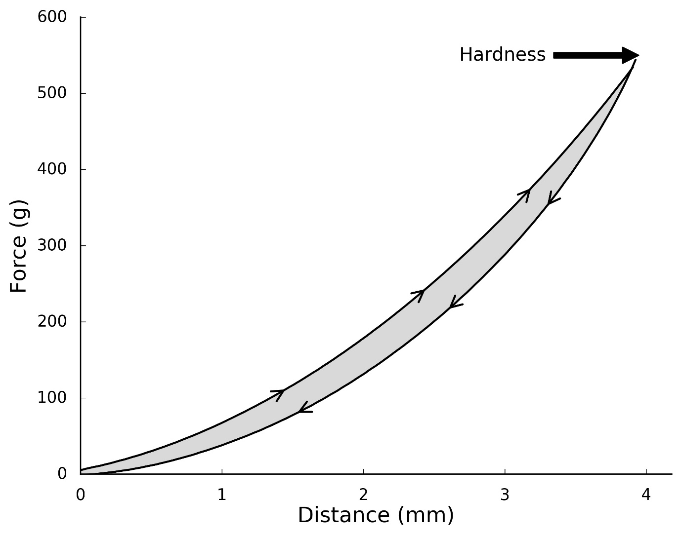
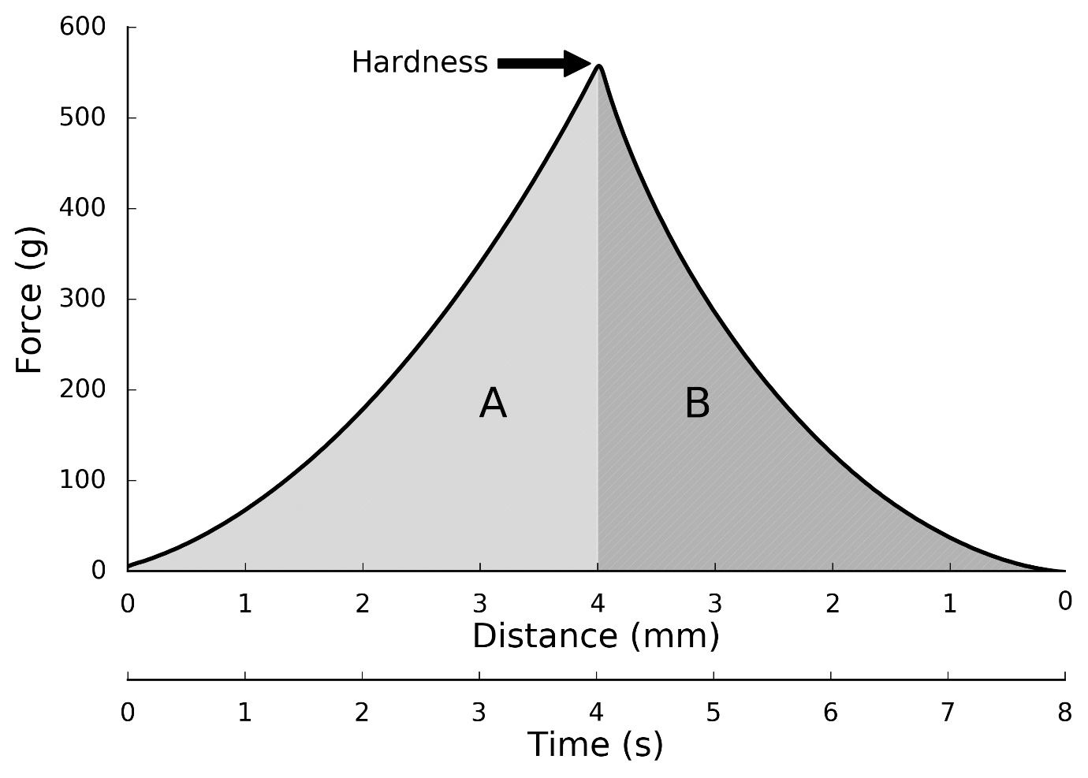
Figure 2. Method of calculation of metrics (for compression and expansion of a Size 2 i-gelTM at 10°C ):
a) Force-Distance plot showing hysteresis loop: Upper curve (right-pointing arrows) and lower curve (left-pointing arrows) indicate relationship during compression and expansion respectively. Hardness (peak force) (g); and energy loss (area enclosed by hysteresis loop; shaded) (g.mm) are shown.
b) Force-Time plot of the same data as a), showing Hardness (peak force) (g); and Resilience (dimensionless quantity), defined as upstroke energy divided by downstroke energy (Area B / Area A ).

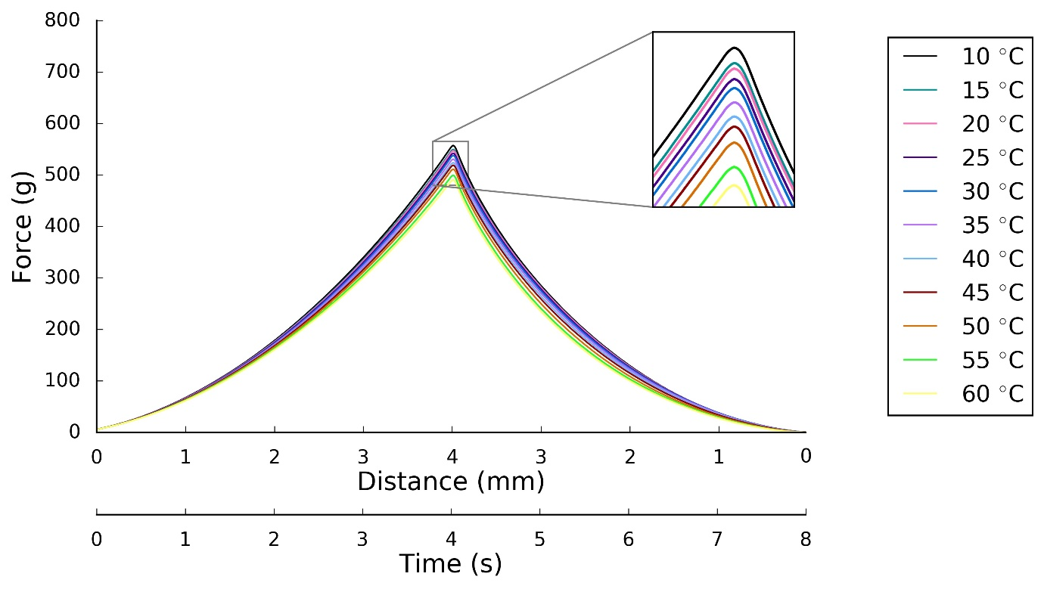
Figure 3. Size 2 LMA: Force (g, y axis) against Distance (mm, Primary x-axis) and Time (s, Secondary x-axis) for isotherms at 10 to 60°C in 5°C increments (each isotherm is the mean of three sets of readings).

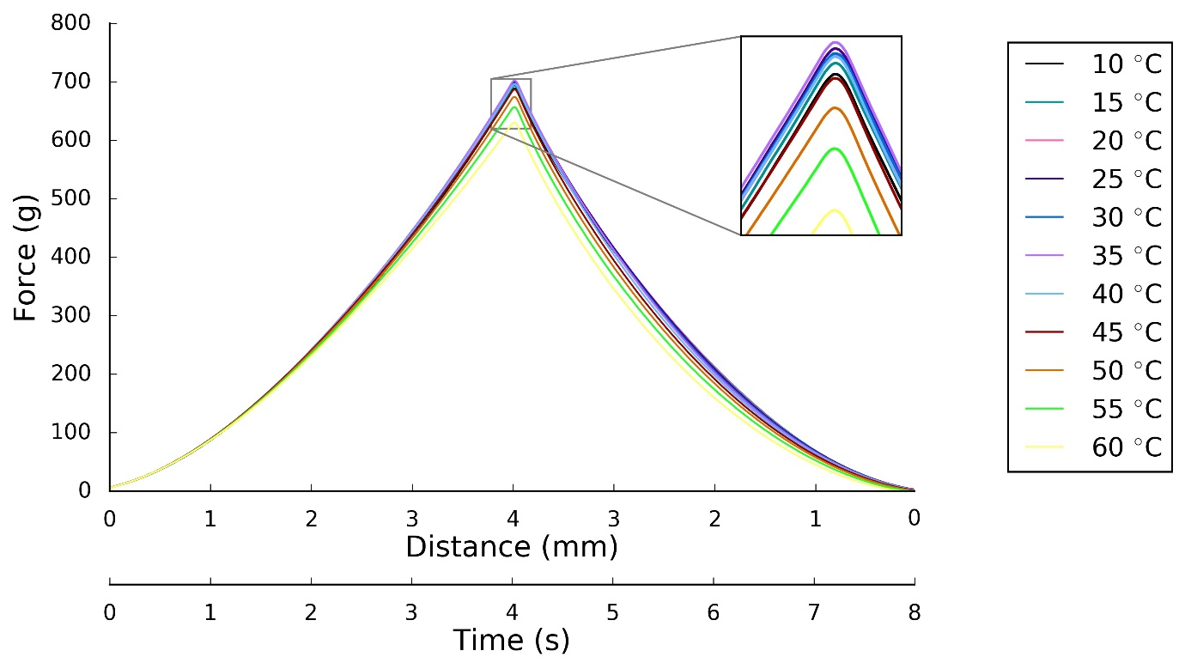
Figure 4. Size 3 LMA: Force (g, y axis) against Distance (mm, Primary x-axis) and Time (s, Secondary x-axis) for isotherms at 10 to 60°C in 5°C increments (each isotherm is the mean of three sets of readings).

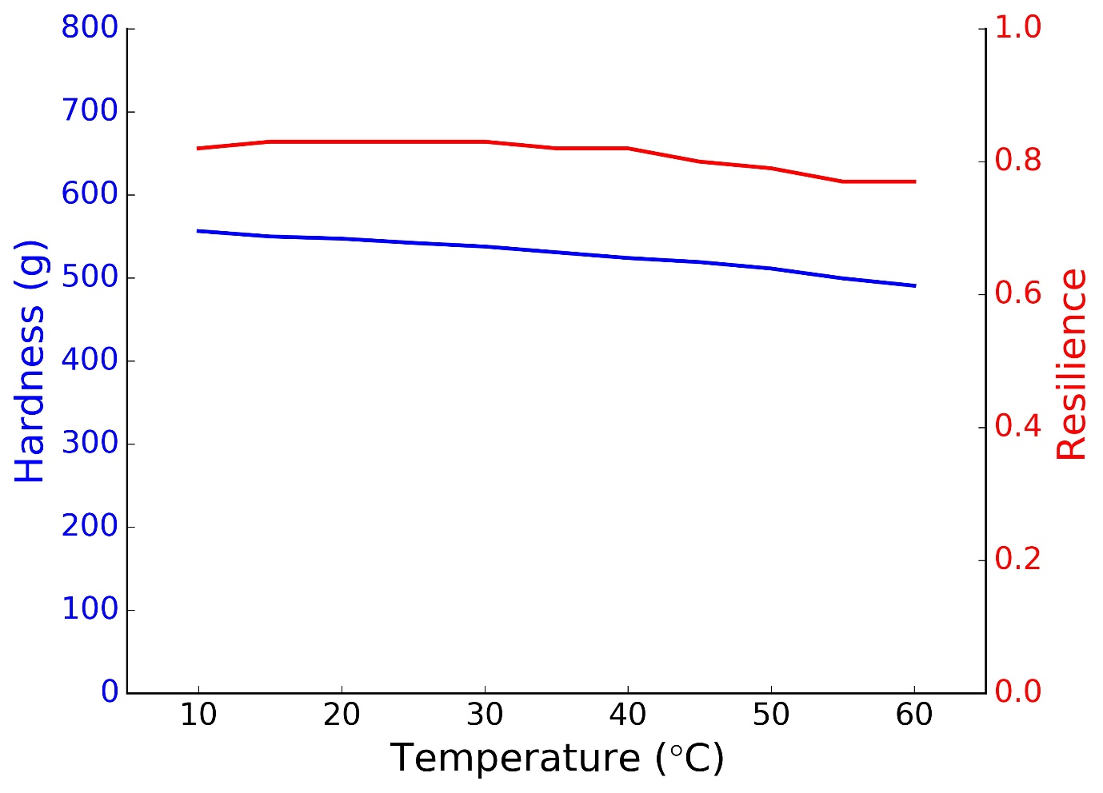
Figure 5. Trend plot of hardness (peak force) and resilience of the size2 i-gelTM cuff with increasing temperature.

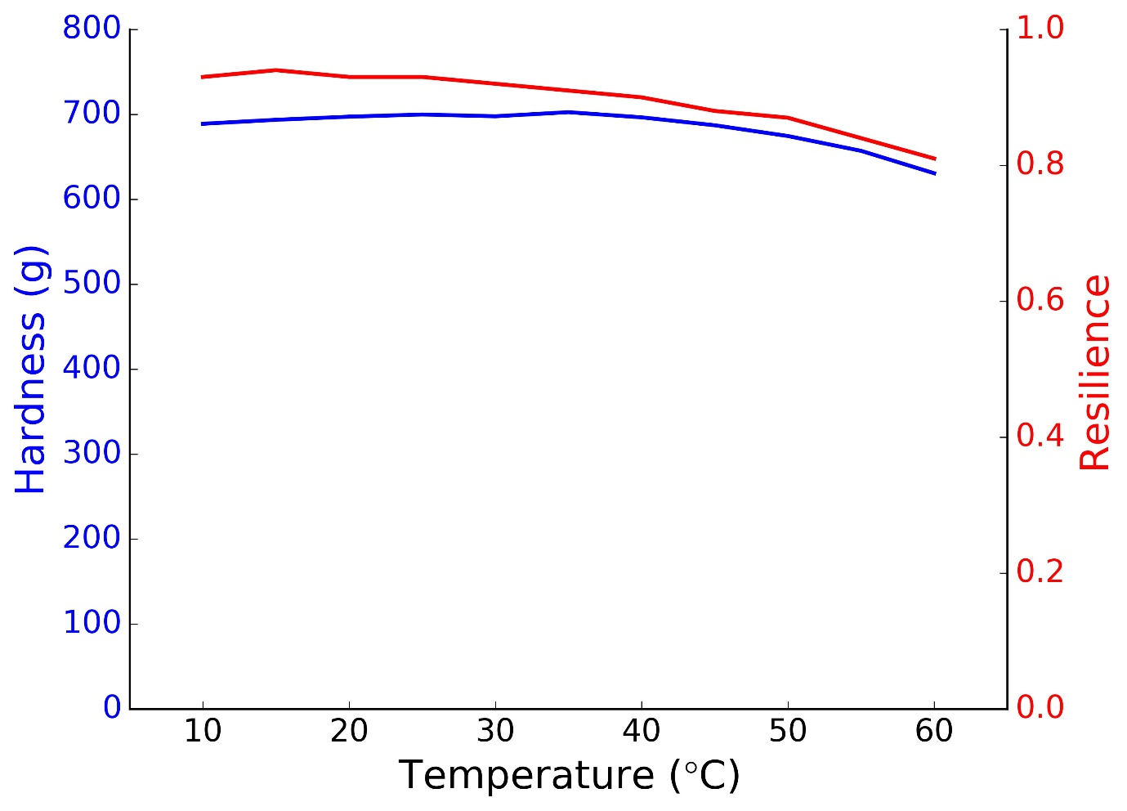
Figure 6. Trend plot of hardness (peak force) and resilience of the size3 i-gelTM cuff with increasing temperature.

